

Project Title

Food Ordering System

Technology:- C Desktop (Functions , Switch , File Handling )
Language:- C Programming Language

Content

Topics:

1.Introduction

2.Purpose

3.Software Hardware Requirement

4.Code Optimization

5.Output

6.Conclusion

7.Reference

Introduction

An online food ordering system can be defined as software that allows restaurant businesses to accept and manage orders placed over the internet. ... First is a website or mobile app for hungry customers to view the restaurant's dishes and place an online order.

Ordering systems are the "mechanical" part of inventory management. They're the programs that take our forecasts, actual orders, safety stock, and, and order quantities, and turn them into purchase orders or production orders. ... The real difference between Push Systems and Pull Systems.

The online food ordering system is one of the latest services most fast food restaurants in the western world are adopting. With this method, food is ordered online and delivered to the customer. This is made possible through the use of electronic payment system. Customers pay with their credit cards, although credit card customers can be served even before they make payment either through cash. So, the system designed in this project will enable customers go online and place order for their food. Due to the great increase in the awareness of internet and the technologies associated with it, several opportunities are coming up on the web. So many businesses and companies now venture into their business with ease because of the internet. One of such business that the internet introduced is an online food ordering system. In today’s age of fast food and take out, many restaurants have chosen to focus on quick preparation and speedy delivery of orders rather than offering a rich dining experience.

Purpose

With the improvement of technology, online food ordering systems are becoming a popular topic. That's because they are serving the ever increasing demand for convince. The main purpose of an online ordering system is to provide customers for a way to place an order at a restaurant over the internet.

With a website or mobile app, customers can easily browse all the dishes the restaurant has available, customize dishes to their requirements and place an order. It can also save their favourite orders allowing them to easily re-order that in the future.
From the restaurants perspective, they no longer spend time taking the customers order, stop worrying about communication errors and streamline their order management workflow.

Software and Hardware requirements

SOFTWARE REQUIREMENTS SPECIFICATION

Operating System : Windows->10
Programming Language : C
User Interface : Console Application
Database : File Handling

HARDWARE REQUIREMENTS SPECIFICATION

Processor : Intel Core
RAM : Minimum of 1GB RAM
Memory : 500 MB or higher

Code Optimization

//---------------------------------------------------------------Food Ordering System In C language------------------------------------------------------------------------------------
#include<stdio.h>
#include<conio.h>
#include<string.h>
#include<stdlib.h>

//-----------------------prototypes of functions---------------------------------------------------
void login();
void home();
void veg();
void Nonveg();
void drinks();
void Breakfast();
void orderConfirm();
void addSomthing();

//------------------------main function-----------------------------------------------------------
void main()
{

FILE *fp;
fp=fopen("login.txt","r");
char username[20],userpassword[20],un[20],up[20];
fscanf(fp,"%s%s",username,userpassword);
printf("Enter The User Name:\n");
gets(un);
printf("Enter The Password:\n");
gets(up);

if((strcmp(username,un)==0)&&(strcmp(userpassword,up)==0))
{
// printf("Login Successfully\n");
printf("Welcome--->%s<---\n",un);
home();
}
else
{
printf("---------------------------------------------------------------------------------\n");
printf("Please Enter currect User Id And Password \n");
printf("---------------------------------------------------------------------------------\n");
login();
}

getch();

}

//------------------------------definations of functions---------------------------------------------
void login()
{
FILE *fp;
fp=fopen("login.txt","r");
char username[20],userpassword[20],un[20],up[20];
fscanf(fp,"%s%s",username,userpassword);
printf("Enter The User Name:\n");
gets(un);
printf("Enter The Password:\n");
gets(up);

if((strcmp(username,un)==0)&&(strcmp(userpassword,up)==0))
{
// printf("Login Successfully\n");
printf("Welcome--->%s<---\n",un);
home();
}
else
{
printf("Please Enter currect User Id And Password \n");
}
}

void home(){
printf("------------------->Welcome To The Restaurant<----------------------------------\n");
printf(" 1 .Veg\n");
printf(" 2 .Non Veg\n");
printf(" 3 .Breakfast\n");
printf(" 4 .Drinks\n");
printf("---------------------------------------------------------------------------------\n");
printf("Enter Your Choice What You Want\n");
int ch;
scanf("%d",&ch);
switch(ch)
{
case 1: printf("You Selected Veg\n");
veg();
break;
case 2:printf("You Selected NonVeg\n");
Nonveg();
break;
case 3:printf("You Selected Breakfast\n");
Breakfast();
break;
case 4:printf("You Selected Drinks\n");
drinks();
break;
default:printf("You Selected Wrong Choice\nPlease Entered Correct Choice\n");
home();
break;
}
}

void veg()
{
printf("---------------------------------------------------------------------------------\n");
printf(" 1 .Paneer Curry\n");
printf(" 2 .Kadai Paneer\n");
printf(" 3 .Daal Fry\n");
printf(" 4 .Sev Bhaji\n");
printf(" 5 .Roti\n");
printf("---------------------------------------------------------------------------------\n");
printf("Select The Option Which You Want:\n");
int ch;
scanf("%d",&ch);
switch(ch)
{
case 1: printf("You Selected Paneer Curry\n");
orderConfirm();
break;
case 2:printf("You Selected Kadai Paneer\n");
orderConfirm();
break;
case 3:printf("You Selected Daal Fry\n");
orderConfirm();
break;
case 4:printf("You Selected Sev Bhaji\n");
orderConfirm();
break;
case 5:printf("You Selected Roti\n");
orderConfirm();
break;
default:printf("You Selected Wrong Choice\nPlease Entered Correct Choice\n");
veg();
break;
}
}

void Nonveg()
{
printf("---------------------------------------------------------------------------------\n");
printf("Select The Option Which You Want\n");
printf(" 1 .Chickan Curry\n");
printf(" 2 .Chickan Mashala\n");
printf(" 3 .Fish curry\n");
printf(" 4 .Fish Fry\n");
printf(" 5 .Roti\n");
printf(" 6 .Chawal\n");
printf("---------------------------------------------------------------------------------\n");
printf("Select The Option Which You Want:\n");
int ch;
scanf("%d",&ch);
switch(ch)
{
case 1: printf("You Selected Chickan Curry\n");
orderConfirm();
break;
case 2:printf("You Selected Chickan Mashala\n");
orderConfirm();
break;
case 3:printf("You Selected Fish curry\n");
orderConfirm();
break;
case 4:printf("You Selected Fish Fry\n");
orderConfirm();
break;
case 5:printf("You Selected Roti\n");
orderConfirm();
break;
case 6:printf("You Selected Chawal\n");
orderConfirm();
break;
default:printf("You Selected Wrong Choice\nPlease Entered Correct Choice\n");
Nonveg();
break;
}
}

void Breakfast()
{
printf("---------------------------------------------------------------------------------\n");
printf("Select The Option Which You Want\n");
printf(" 1 .Poha Sev\n");
printf(" 2 .Poha Sev Jalabi\n");
printf(" 3 .Samosa\n");
printf(" 4 .Cachori\n");
printf("---------------------------------------------------------------------------------\n");
printf("Select The Option Which You Want:\n");
int ch;
scanf("%d",&ch);
switch(ch)
{
case 1: printf("You Selected Poha\n");
orderConfirm();
break;
case 2:printf("You Selected Poha Sev Jalabi\n");
orderConfirm();
break;
case 3:printf("You Selected Samosa\n");
orderConfirm();
break;
case 4:printf("You Selected Cachori\n");
orderConfirm();
break;
default:printf("You Selected Wrong Choice\nPlease Entered Correct Choice\n");
Breakfast();
break;
}
}

void drinks()
{
printf("---------------------------------------------------------------------------------\n");
printf("Select The Option Which You Want\n");
printf(" 1 .Normal Water\n");
printf(" 2 .Child Water\n");
printf(" 3 .Pepsi\n");
printf(" 4 .Juice\n");
printf("---------------------------------------------------------------------------------\n");
printf("Select The Option Which You Want:\n");
int ch;
scanf("%d",&ch);
switch(ch)
{
case 1: printf("You Selected Normal Water\n");
orderConfirm();
break;
case 2:printf("You Selected Child Water\n");
orderConfirm();
break;
case 3:printf("You Selected Pepsi\n");
orderConfirm();
break;
case 4:printf("You Selected Juice\n");
orderConfirm();
break;
default:printf("You Selected Wrong Choice\nPlease Entered Correct Choice\n");
drinks();
break;
}
}

void orderConfirm()
{
printf("---------------------------------------------------------------------------------\n");
printf("Confirm Your Oder Just Click Please\n");
printf("---------------------------------------------------------------------------------\n");
printf("1.Yes\n");
printf("2.No\n");

int ch;
scanf("%d",&ch);
switch(ch)
{
case 1:printf("Your Order Is Successfull On The Way\n");
addSomthing();
break;
case 2:printf("Sorry! Canceled Your Order\n");
break;
default:printf("You Entered Wrong Choice\nPlease Entered Correct Choice\n");
orderConfirm();
break;
}

}

void addSomthing()
{
printf("---------------------------------------------------------------------------------\n");
printf("Do You Want To Add Somthing Else!\n");
printf("---------------------------------------------------------------------------------\n");
printf("1. Yes\n");
printf("2. No\n");
int ch;
scanf("%d",&ch);
switch(ch)
{
case 1:printf("Iteam Added Successfully \n");
home();
break;
veg();
break;
Nonveg();
break;
drinks();
break;
Breakfast();
break;
case 2:printf("---------------------------------->Visit Again<----------------------------------");
break;
default:printf("You Entered Wrong Choice\nPlease Entered Correct Choice\n");
addSomthing();
break;
}

}

Output

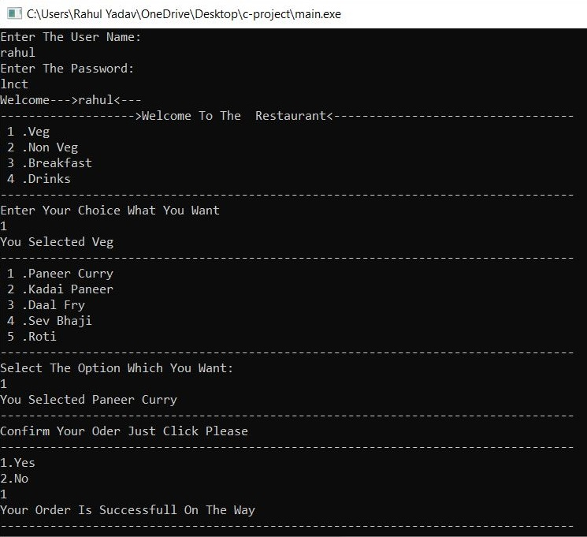

Conclusion

Customer Experience:-
It is a fact, if your customers like your service, they will come back and also recommend you to their world. They will become your best advertisers. So, you need to commit to a service that keeps them coming back
It can be done by making the ordering process convenient for them. Eventually, this “convenience” will pay huge dividends for your restaurant. One thing is certain that people don’t like to order their food over the phone. Everyone wants to place their order without fuss and undoubtedly, asap.

Web Presence:-

Managing a restaurant in these times means that you need to have a strategic online representation.
Your business needs to maintain a competent presence at various search engines and social media platforms.

Productivity:-

Instead of wasting time taking orders over the phone, orders can be received online, and the orders received from the customers directly have matchless accuracy.

REFERENEES

websites
- W3school.com
- Javatpoint.com

Books
- Book->Let uc c

